Trial Lawyers Care: Case Analysis

Every one of the nearly 1,100 TLC lawyers is a trial lawyer or had the guidance of trial lawyers. They did not just maximize the awards to 9/11 victims. In many cases it was as difficult or harder to help their clients to move on by making a decision. The high percentage of filings testifies to their success.

The average awards they achieved demonstrates the tangible value of their lawyering; to date TLC lawyers achieved awards on death claims averaging $2,146,714 or 4% more than the other awards. This is even more astonishing when the profile of TLC claims is considered. About twice as many, or 20%, of the non-TLC claims were for decedents in the high-income category, $220,000+, for which the average award was over $4 million.

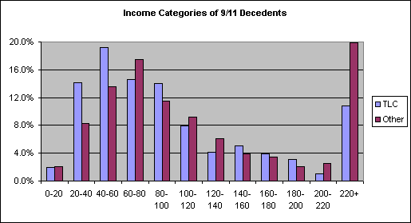

As the chart shows, TLC lawyers handled a much higher portion of the low-income cases, those in the $20-40,000 and $40,000-60,000 categories. It is not surprising that trial lawyers would care greatly about these families, and work very hard for them. The results bear this out. In the $20-40,000 category the average award achieved by TLC lawyers was $1,152,840, $85,739 or 8% higher than the rest. In the $40-60,000 category the average award achieved by TLC lawyers was $1,402,696, $246,672 or 21% higher than the rest.

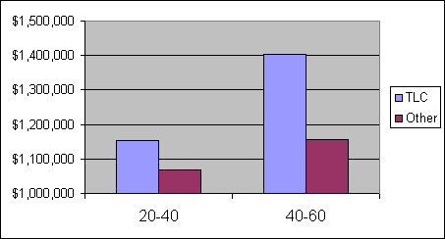

But TLC's lawyers did not fail to work just as hard for high-income families. In this category the average award achieved by TLC lawyers was $4,061,160, slightly above the average, even though most of the ultra-high income Cantor Fitzgerald cases were farmed out to paid corporate law firms.

Finally, and perhaps most importantly, TLC lawyers achieved an average of about $700,000 over the presumed or table amounts for death claims. Multiplying this average by the total of 843 PR-death claims results in a total of $590 million additional contribution from trial lawyers for the victim families. They did this -- as only trial lawyers can do -- by proving the most probable actual losses to real people, including those for decedents who were expected to outperform the charts, replacement services, lost employee benefits, single people who supported others or were about to marry, claimants with special needs children, survivors who did not benefit from life insurance proceeds, etc.

Trial lawyers worked these miracles one case at a time. They helped victims and most found themselves transformed by the experience.

Paul

Paul S. Holdorf
Trial Lawyers Care
Phone: (917) 464-0105 ext. 518
Fax: (917) 464-0160
paul.holdorf@911lawhelp.org

